Bangladesh University of Business and Technology (BUBT)
Department of Computer Science and Engineering (CSE)


Project Report
Stellar Salvage
A Hex-Grid Resource-Collection Game with Adversarial Search

Submitted By:
Syeda Jannatul Mawa - 20245103218
Salman Farsi Bijoy- 20245103228
Ashraful Islam - 20245103367

Submitted To:
Mohtasim Fuad
Department of CSE, BUBT

Date of Submission: August 16, 2026

Introduction
Stellar Salvage is a two-player, turn-based strategy game played on a hexagonal grid, in which a human player competes against a computer-controlled rival ship to collect the most “salvage” before both ships run out of places to go. The project was built to demonstrate the practical application of classical adversarial search, specifically the Minimax algorithm with alpha-beta pruning to a game with mechanics that go beyond a standard textbook example.
The core rule that gives the game its character is terrain collapse: the hex sector a ship leaves is permanently destroyed the instant it moves away. This guarantees that the playable area strictly shrinks every turn, which has two consequences that shape the rest of the design. First, it guarantees the game tree is finite and the game must terminate, which is what makes exhaustive or near-exhaustive search meaningful. Second, it means the two ships are competing over mobility as much as over the sector values themselves: stranding an opponent, or avoiding being stranded, is often more important than the raw value of the next move.
A second design element, the wormhole (a hex with a negative value), was added deliberately to test whether the search and evaluation logic generalise correctly to losses as well as gains, without needing any special-case code. This report documents the theoretical basis, architecture, algorithm, implementation, interface, and empirical results of the finished system.

Background and Theoretical Framework
Stellar Salvage belongs to the class of deterministic, perfect-information, zero-sum, two-player games in the same category as Chess, Checkers, and Othello with one notable relaxation of the usual strict-alternation rule (discussed below). Because both players can see the entire board at all times and no chance element (such as a die roll or hidden card) affects the outcome, the game is a valid candidate for adversarial tree search, where each player is assumed to play optimally against an opponent who is also trying to win.

Minimax
The Minimax algorithm evaluates a game tree by alternating between a maximising player (the AI) and a minimising player (the human), on the assumption that each side always chooses the move that is best for itself and worst for its opponent. At a fixed search depth, positions that are not yet terminal are scored by a heuristic evaluation function rather than being searched to the true end of the game, because the full game tree is too large to explore exhaustively within an interactive time budget.

Alpha-Beta Pruning
Alpha-beta pruning is an optimisation of Minimax that discards (“prunes”) branches of the search tree that cannot possibly affect the final decision, without changing the result the algorithm would have produced anyway. It maintains two bounds, alpha (the best value the maximiser can already guarantee) and beta (the best value the minimiser can already guarantee); once alpha meets or exceeds beta at a node, the remaining siblings at that node are skipped. In the best case this reduces the effective branching factor from O(b^d) to approximately O(b^(d/2)).

Why the Game Is Guaranteed to Terminate
A general two-player game is not guaranteed to end, which is why some Minimax implementations need explicit repetition detection or move limits. Stellar Salvage avoids this problem structurally: because every move permanently removes a hex from play and no move can ever be reversed, the number of remaining playable hexes is strictly decreasing. This means the recursive search in this project never needs cycle detection, and termination is a mathematical guarantee rather than an assumption.

Relaxing Strict Alternation
Standard Minimax assumes players strictly alternate turns, and typically treats “no legal move” as an immediate end of game (as in Chess) or a pass (as in Go). Stellar Salvage uses a third option: a stranded ship sits out while its opponent continues taking turns alone, and the game only ends once both ships are simultaneously unable to move. This required extending the search so that, at any node, a side with no legal moves defers to its opponent rather than the search terminating early or assuming strict alternation detailed further in the AI Methodology section.

Software/Hardware Used
Component | Choice | Notes
Language | Python 3.12 | Standard CPython interpreter; no compiled extensions required.
Rendering / Input | pygame 2.6.1 (SDL 2.28.4) | Handles the window, event loop, drawing primitives, and font rendering.
Standard Library | math, random | math for hexagon trigonometry; random for board generation and the Easy AI.
Version Control | Git / GitHub | Source is organised as a standard Python package with a .gitignore and README.
Hardware Requirements | Any CPU capable of running Python 3 | No GPU, network, or specialised hardware is required; the AI search runs entirely on the CPU in well under one second per move (see Results).
The project has no external dependencies beyond pygame; it does not use any machine learning framework, as the rival ship's intelligence is produced entirely by classical search rather than a trained model.

System Architecture and State Representation
The codebase is deliberately split into three files along a strict responsibility boundary: game rules and AI versus presentation.
Module | Responsibility | Depends On
game_logic.py | Hex grid geometry, game state, move legality, board generation, and both AI difficulty levels. Contains no references to pygame. | math, random
ui.py | Window, rendering, input handling, turn scheduling, and the main loop. | pygame, game_logic
main.py | Entry point; constructs and runs the Game object. | ui
This separation means the rules and the AI can be exercised, tested, or reused without a display every automated test referenced in the Results section runs the logic module headlessly, with no window ever created.

Hex Grid Representation
Hexes are addressed using axial coordinates (q, r), a standard two-coordinate scheme for hexagonal grids that is convenient for both neighbour lookup and distance calculation. A grid of radius R consists of every (q, r) pair for which the implied third cube coordinate, s = −q − r, satisfies max(|q|, |r|, |s|) ≤ R. Each hex has exactly six neighbours, reached by adding one of six fixed offset vectors to (q, r). Screen-space pixel positions are derived from axial coordinates using the standard pointy-top hexagon projection formulas, parameterised by a hex size that is scaled per board size so that Small, Medium, and Large boards all fit the same window.
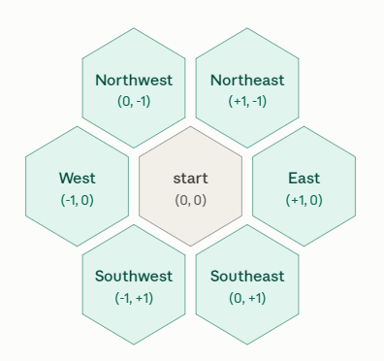

Game State
A game state is a plain Python dictionary rather than a custom class, chosen specifically because the AI search needs to clone the state many times per move and dictionary/set copying is inexpensive and explicit. Its fields are:
Field | Type | Description
grid | HexGrid instance | Shared by reference across clones geometry never changes during a game, so it is not copied.
player_pos / ai_pos | (q, r) tuple | Current hex occupied by each ship.
player_banked / ai_banked | integer | Running salvage total; can go negative after a wormhole.
values | dict: (q, r) → integer | Remaining value of each hex; set to 0 once collected.
collapsed | set of (q, r) | Hexes that have been vacated and are now permanently impassable.
difficulty / level / over | string / string / boolean | Rival difficulty, board-size preset, and whether the run has ended.
Cloning a state for search (clone_state) copies the mutable fields positions, banked totals, the values dictionary, and the collapsed set but reuses the same HexGrid object, since grid geometry is fixed for the life of a game. This keeps each node of the search tree cheap to create.

AI Methodology and Algorithm
The rival ship offers two difficulty tiers, selectable from the interface, which use entirely different decision procedures rather than the same algorithm at different depths.

Easy: One-Ply Greedy Heuristic
Easy mode looks only one move ahead. For each legal move it computes a score equal to twice the salvage value that move would collect, plus half of the mobility (legal-move count) that results from making it, plus a small random term used purely as a tie-breaker so that the Easy AI does not play identically every game. It then takes the highest-scoring move. This produces a rival that behaves sensibly it will grab obviously valuable tiles without anticipating the human player's response.

Hard: Minimax with Alpha-Beta Pruning
Hard mode performs a full Minimax search to a fixed depth of six plies (SEARCH_DEPTH = 6), with alpha-beta pruning applied at every node. The AI is the maximising player and the human is the minimising player, consistent with the evaluation function below being defined as (AI advantage − player advantage).

Evaluation Function
Non-terminal positions reached at the depth cutoff are scored by a two-term linear evaluation function:
evaluate(state) = (ai_banked − player_banked) × 1.0 + (ai_mobility − player_mobility) × 0.35
Term | Weight | Purpose
Banked-value difference | 1.0 | The primary objective salvage collected is what actually decides the winner.
Mobility difference | 0.35 | A secondary, smaller-weighted term that rewards keeping more legal moves open than the opponent, which lets the AI use stranding as a tactic without letting it override real salvage gains.
At a true terminal position (both ships stranded), the mobility term is dropped entirely and the position is scored purely on banked-value difference, since mobility is meaningless once the run has actually ended.

Turn-Skip Handling Inside the Search
Because a stranded ship sits out rather than ending the game, the search itself has to model that behaviour, not just the top-level game loop. At every node, if the side to move has no legal moves, the algorithm checks the opponent: if the opponent is also stranded, the node is terminal and is scored directly; otherwise the turn is handed to the opponent at the same search depth, at no cost to the remaining depth budget, since no actual decision was made. This means the Hard AI can correctly plan several moves ahead through a sequence that includes stranding the player early to gain a run of uncontested extra turns, a strategy that a textbook alternating-turn Minimax could not represent.

Complexity
Each hex has at most six neighbours, so the branching factor of the search tree is at most six at any node (fewer as the board fills in). With a fixed depth of six plies, the theoretical worst case without pruning is on the order of 6^6 ≈ 46,656 leaf evaluations per move; empirical results (see Results) show pruning reduces this by roughly two orders of magnitude in practice.

Implementation Details

Board Generation
Each new game calls generate_board, which independently rolls a value for a random subset of non-starting hexes: 32% of eligible hexes receive a salvage value drawn from a weighted pool biased toward lower “wreck” values (2–3) over rarer high-value “crystal” values (4–5), and 14% receive a wormhole value drawn from a separate negative pool (−2 to −4). The centre hex, when present, is handled separately and drawn from its own pool that is weighted toward high value but can occasionally be a wormhole, making it a contested but risky objective. Values are generated with Python's random module; passing an explicit seed produces a reproducible board (used for testing), while normal gameplay passes no seed so every “New Game” produces a genuinely different, unbalanced layout between the two starting positions.

Move Application and the Collapse Mechanic
apply_move performs three actions atomically: it adds the ship's current hex to the collapsed set, updates the ship's position to the destination hex, and if that hex still holds a non-zero value adds that value to the ship's banked total and zeroes the hex so it cannot be collected twice. Because the same function handles both positive and negative values without branching on sign, wormholes required no special-case logic anywhere in the move or search code; they fell out of the existing arithmetic naturally.

Turn Management and Stranding
Turn flow is coordinated by a small recursive dispatcher, proceed(mover), in the UI layer. If the side to move has legal moves, it acts (or, for the AI, a short delay is scheduled before it acts, so its move is visible rather than instantaneous). If it has no legal moves, the dispatcher checks whether the opponent also has none; if so the run ends, and otherwise the turn is silently handed to the opponent, who continues alone. A stranded side is only announced once in the move log, not on every subsequent turn, to avoid flooding the log during a long solo run.

Randomisation and Reproducibility
Two independent sources of randomness are used: fresh_state's board generation (seedable, for testing) and the Easy AI's tie-breaking term (always unseeded). The Hard AI is entirely deterministic given a board and position; it has no random component which was verified during testing by confirming that repeated searches from an identical cloned state always return the same move.

UI Elements
The interface is a single pygame window divided into three regions.

Header
- Title and a one-line rule summary.
- A live status line showing the current board size and rival difficulty.
- Two rows of toggle buttons: rival difficulty (Easy / Hard) and board size (Small / Medium / Large); changing either starts a new game.
- A New Game button that regenerates the board..

Map Panel
- The hex grid itself, with each hex's fill and border style indicating its state: empty, holds salvage, holds a wormhole (H-value), collapsed (marked with red shadow), or a ship's starting position.
- Legal destinations for the human player are outlined and rendered thicker so they are unambiguous before every click.
- The two ships are drawn as labelled circular markers (“Y” for the player, “R” for the rival) that move between hex centres as the game progresses.
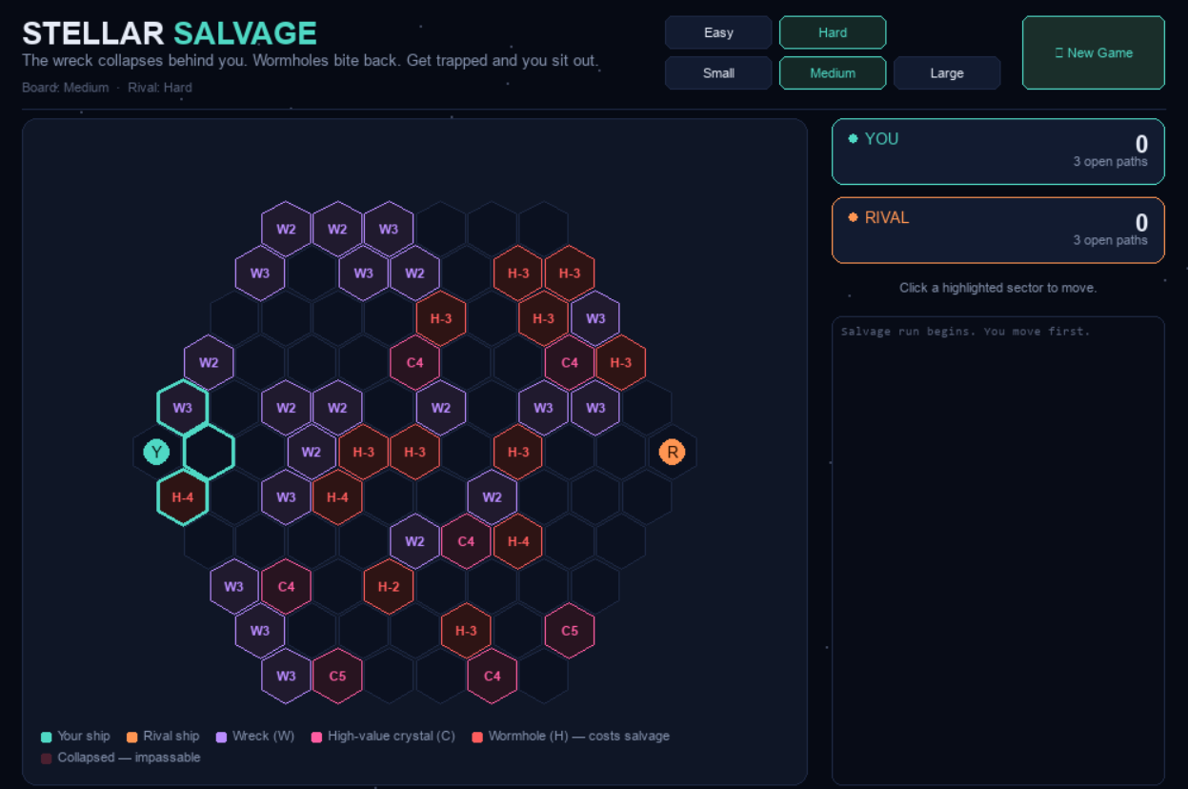

Side Panel
- Two ship cards showing each side's banked total and remaining open-path count, updated every frame.
- A status line reporting whose turn it is, or that the rival is currently searching.
- A scrolling move log recording every move, salvage gained or lost, stranding events, and the final result, with word-wrapping so long entries remain readable
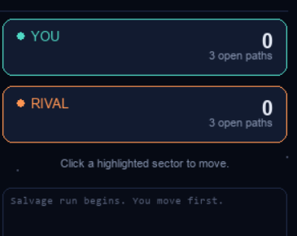

Game-Over Overlay
When the run ends, a modal panel reports the winner (or a tie), the reason the run ended, and both final totals, with a button to start a new game immediately.

Input Handling
Mouse clicks are resolved against the six-cornered polygon of each hex using a standard even-odd ray-casting point-in-polygon test, rather than a simpler bounding-box or centre-distance approximation, so that clicks near a hex's edge are attributed to the correct neighbouring hex.

Results
The system was validated with automated, headless playthroughs (no window rendered) across every combination of board size and difficulty, using randomised legal moves for the human side to stress-test edge cases such as stranding, turn-skipping, and negative-value tiles. All trials terminated correctly with a valid winner or tie determined purely by final banked totals.

Board Composition by Level
Level | Radius | Total Hexes | Salvage Hexes | Wormhole Hexes
Small | 4 | 61 | 20 | 8
Medium | 5 | 91 | 29 | 12
Large | 6 | 127 | 40 | 18

Hard-AI Search Performance (First Move)
Nodes searched and wall-clock time for the AI's opening move at each board size, with alpha-beta pruning active and search depth fixed at 6:
Level | Nodes Searched | Time (ms) | Theoretical Worst Case (no pruning)
Small | 660 | 3.0 | ≈ 46,656
Medium | 637 | 4.4 | ≈ 46,656
Large | 581 | 3.1 | ≈ 46,656
In every case, alpha-beta pruning reduced the number of positions actually evaluated by roughly two orders of magnitude relative to the unpruned worst case, while producing an identical result to what an unpruned search would have found. Across a full game, the worst single-move latency observed for the Hard AI on the largest board was approximately 30–70 milliseconds, comfortably inside the 500-millisecond “thinking” delay built into the interface search time that is never perceptible to the player during normal play.

AI Strength
To sanity-check that the Hard AI's search actually translates into stronger play rather than merely running without errors, it was pitted against a uniformly random move-selecting player over 40 automated games on the Medium board. The Hard AI won all 40 games (100%), with no ties and no losses, confirming that the evaluation function and search depth are sufficient to reliably outperform unplanned play under the current rule set.

Correctness Under the Extended Turn Rule
Specific test scenarios confirmed that a stranded side is correctly skipped exactly once (no repeated log spam), that the surviving side continues to bank salvage across multiple consecutive turns while its opponent is stranded, that the run only ends once both sides are simultaneously unable to move, and that the winner is always determined purely by final banked total including cases where banked totals were negative due to wormholes.

Conclusion
Stellar Salvage demonstrates that classical Minimax search with alpha-beta pruning remains a practical and effective technique for real-time, interactive game AI, even outside the two-player board games it is most commonly taught on. Adapting the algorithm to a game with permanently mutating terrain, an unconventional turn-skipping rule, and negative-value tiles required extending the search's handling of terminal and stranded states, but did not require abandoning the algorithm itself the same evaluation function and pruning logic handle gains and losses, and stranded and active turns, without special-case branching for sign or for who is currently able to move.
The empirical results support the design choices made: search remains fast enough (single-digit to low-double-digit milliseconds per move) to be imperceptible during play even on the largest board, pruning delivers roughly a hundred-fold reduction in nodes evaluated relative to the unpruned worst case, and the Hard AI reliably outperforms unplanned play, winning every game against a random-move opponent in testing.

Limitations
- Search depth is fixed at six plies rather than adjusted dynamically (for example, via iterative deepening within a time budget), so search cost does not automatically scale down on very large boards or up when more thinking time could be afforded.
- No move ordering or transposition table is used; nodes are visited in the order Python's dictionary iteration happens to produce, rather than being sorted to maximise pruning as is common in stronger engines.
- Board generation, while randomised, uses fixed percentage constants for salvage and wormhole density rather than exposing them as a tunable difficulty parameter.

Future Work
- Move ordering (for example, searching high-value hexes first) to increase the effective pruning rate.
- A transposition table to avoid re-searching board states reachable by more than one move sequence.
- Iterative deepening with a time budget, allowing search depth to adapt to board size automatically.
- Exposing salvage and wormhole density as an additional difficulty axis, independent of search depth.

